SYSTEM ANALYSIS FOR INNOCENCE PROJECT NATIONAL CAPITAL REGION (IPNCR) CAPSTONE

Johns Hopkins University

May 1, 2002

Prepared By:

John Duffy
Mike Vaidya
Andrea Van Pelt
John Weinheimer

Table of Contents

1.1 Purpose/Scope (JTD) 1
2.0 System Requirements (JD/JW) 1
2.1 Public Relations (Public Site) 1
2.1.1 Overview of Innocence Project 1
2.1.2 Recent successes, upcoming events, news, etc. 1
2.1.3 How to contribute money 1
2.1.4 How to volunteer 1
2.1.5 Logo/branding label for DC Innocence Project 1
2.1.6 Downloadable Innocence Project Applications 1
2.2 Administrative (Staff and Students and Lawyers Handling Cases) 1
2.2.1 Current case list 1
2.2.2 Monthly status report function 1
2.3 Research material (Public Site) 2
2.3.1 Links to external web sites and agencies 2
2.4 Resources 2
3.0 Functional Design (JTD) 1
3.1 System Definitions 1
4.0 Evaluation Criteria 2
5.0 Hardware Options 2
5.1 Hosting 2
5.1.1 American University Law School (AVP) 2
5.1.2 Outsource 3
5.1.3 Business Partnership (e.g. NLDA) (AVP) 5
6.0 Software Options 6
6.1 External Site 7
6.1.1 HTML Editor (JTD) 7
6.1.2 Document Converter (MV) 7
6.2 Internal Site 7
6.2.1 AMICUS Attorney Software (AVP) 7
6.2.2 ZOP Software (JW) 8
6.2.3 Custom Made Database (JW) 8
7.0 Information Assurance Options 9
7.1 Site Security (MV) 9
7.2 Backups (JW) 9
7.3 Inter Organizational agreement (JW) 10
8.0 System Options 10
9.0 Summary/Conclusion (JD) 11

Table of Tables

Table of Figures
Figure 1. Functional Block Diagram 1
Figure 2. NLDA Web-Site 5
Figure 3. NLDA Web-Site (cont.) 6

Purpose/Scope
The following is a system analysis for a web-based application that includes requirements, functional design, implementation options and analysis of alternatives. This document provides an overview and assessment of options for components needed for implementation.

System Requirements

Public Relations (Public Site)
Design a publicly accessible IT-based application that includes the following:

Overview of Innocence Project
The public side of the IT-based application will provide and overview of the Innocence Project to include mission overview, history, and contact information.

Recent successes, upcoming events, news, etc.
The public side of the IT-based application will provide current events on the organization to include recent successes and upcoming events on the project.

How to contribute money
The public side of the IT-based application will provide procedures and contact information for prospective donors who want to contribute to the project.

How to volunteer
The public side of the IT-based application will provide procedures and contact information for individuals and group who seek to provide volunteer work to the Innocence Project.

Logo/branding label for DC Innocence Project
The public side of the IT-based application will contain graphics for a Innocence Project logo.

Downloadable Innocence Project Applications
The public side of the IT-based application will offer electronic versions of documents relevant to Innocence Project operations for download.

Administrative (Staff, Students and Lawyers Handling Cases)
Design a password protected IT-based application that includes the following:

Current case list
The administrative side of the IT-based application will contain a list of current cases for reference. Students and lawyers will be allowed to “mark” changes to the case list, which would be subject to review and acceptance/rejection, by administrative staff.

Monthly status report function
The administrative side of the IT-based application will contain a monthly status report function. Options for this function could be a blank form to be completed and emailed by students and lawyers handling cases

Research material (Public Site)
Design an IT-based application accessible by the public with links and/or citations to the following types of information.

Links to external web sites and agencies
The public side of the IT-based application will provide links to external websites and agencies that provide relevant and supporting information on the program:

- DNA research
- Current legislation
- Briefs filed in Innocence Project cases

Resources
The resources needed to implement will be identified for IT-based solution to include:
- Site Hosting
- Hardware requirements (e.g. servers, connectivity, etc.)
- Software requirements (e.g. browsers, document writers, HTML editors, etc.)

Functional Design (JTD)
below is a functional block diagram for the design of the IPNCR web based solution.
Figure 1. Functional Block Diagram

System Definitions
www.webopedia.com provide definitions for each component shown in above.

Remote Access - The ability to log onto a network from a distant location. Generally, this implies a computer, a modem, and some remote access software to connect to the network.

End User – The final or ultimate user of a computer system. The end user is the individual who uses the product after it has been fully developed and marketed. (e.g., IPNCR personnel, Lawyers, Prospective Applicants, Volunteers, etc.)
Internet - A global network connecting millions of computers. More than 100 countries are linked into exchanges of data, news and opinions. Unlike online services, which are centrally controlled, the Internet is decentralized by design. Each Internet computer, called a host, is independent. Its operators can choose which Internet services to use and which local services to make available to the global Internet community. There are a variety of ways to access the Internet. Most online services, such as America Online, offer access to some Internet services. It is also possible to gain access through a commercial Internet Service Provider (ISP).

Host - A computer system that is accessed by a user working at a remote location. Typically, the term is used when there are two computer systems connected by modems and telephone lines. The system that contains the data is called the host, while the computer at which the user sits is called the remote terminal.

Website - A site (location) on the World Wide Web. Each Web site contains a home page, which is the first document users see when they enter the site. The site might also contain additional documents and files. Each site is owned and managed by an individual, company or organization.
Firewall - A system designed to prevent unauthorized access to or from a private network. Firewalls can be implemented in both hardware and software, or a combination of both. Firewalls are frequently used to prevent unauthorized Internet users from accessing private networks connected to the Internet, especially intranets. .
Server - A computer or device on a network that manages network resources. For example, a file server is a computer and storage device dedicated to storing files. Any user on the network can store files on the server.
Database - A collection of information organized in such a way that a computer program can quickly select desired pieces of data. You can think of a database as an electronic filing system. Fields, records, and files organize traditional databases. A field is a single piece of information; a record is one complete set of fields; and a file is a collection of records. For example, a telephone book is analogous to a file. It contains a list of records, each of which consists of three fields: name, address, and telephone number. For the IPNCR, the Research database will consist of records containing case information.

Administrative Application - A program or group of programs designed for end users. For the IPNCR, the application will provide administrative functions to include current case list and status reports.
System Administrator - An individual responsible for maintaining a multi-user computer system, including a local-area network (LAN). Typical duties include:
- Adding and configuring new workstations
- Setting up user accounts
- Installing system-wide software
- Performing procedures to prevent the spread of viruses
- Allocating mass storage space
The system administrator is sometimes called the sysadmin or the systems administrator. Small organizations may have just one system administrator, whereas larger enterprises usually have a whole team of system administrators.

System Options
Based on fact-finding, research and interviews with IPNCR, the JHU Capstone Team has 3 primary options for implementing the web-based solution described above.

In – House – American University hosts public/private site, administrative application using Commercial Off The Shelf (COTS) .(eg., AMICUS Attorney )product and provide operations and maintenance support.

Business Partnership – National Legal Aid & Defender Association (NLADA) hosts public/private site, administrative application using Open Source Code Application (i.e. ZOPE) and provide operations and maintenance support.

Outsourcing – Commercial Application Service Provider (ASP) hosts public/private site, administrative application using custom designed product and provide operations and maintenance support.

Evaluation Criteria
Hardware, software and security options are evaluated for the following criteria as applicable.
- Functionality – Measure of how a particular component or application meets stated requirements
- Scalability – Measure of how well a hardware or software system can adapt to increased demands
- Reliability – Measure of the ability of a system or component to perform required functions under stated conditions for a specified period of time
- Portability – Measure of how easily a hardware component can be physically moved or how software has the ability to run on a variety of computers
- Organizational Constraints – Measure of how well the system fits the requirements of multiple organizations
- Cost – Potential cost impact for a particular hardware/software selection.

Hardware Options
The following describes and evaluates several hardware options for hosting the IPNCR web based solution.

Hosting
An evaluation of the current IT technology IPNCR presents three hosting options: that can be supported by In-House (i.e., American University), Business Partnership (i.e. NALDA), and Outsourcing (i.e., Application Service Provider). Based on a series of fact-gathering meetings with IPNCR, these options have been examined for potential hosting opportunities. Each option is assessed for functionality, scalability, reliability, portability, organizational constraints, and costs.

American University (AU) Law School (AVP)

Introduction:
American University currently has a small office for the Innocence Project personnel. Within that office there are 2 workstations that are used for accessing AU’s Intranet for Innocence client research. AU personnel and their IT infrastructure has the resources to provide support to the IPNCR internal/external website. However, the AU internal network does not provide remote connectivity to IPNCR personnel.

- Functionality – AU has the capability to provide functionality of all applications that will meet IPNCR’s needs.
- Scalability –. AU has the infrastructure to meet the needs of IPNCR. It is assumed that AU has the capability to expand due to increased demand
- Reliability – This option is reliable assuming that maintenance, data recovery and information assurance processes are in place.
- Portability – Currently there are no written agreements in place that allow IPNCR to remove software/hardware and data from AU facility.
- Organizational Constraints – This option will be a restricted or confined option as it only allows access within the prescribed bounds of AU. This option may be too restrictive for the IPNCR’s organizational mission.
- Migration Opportunities – This option does allows for IPNCR at some point the ability to move client files off the AU site and onto another ISP or in-house web-site, but may be time consuming and agreement driven.
- Cost – The expenditure of time and labor, necessary for the attainment of a keeping updated files and research not be worthwhile. To have the web-site hosted may cause data loss because it may get regular backups, or proper maintenance. All of which is a service but this is not in their control. Also, they may suffer from no dial-up features, or sacrifice not being able to link to the Internet: Participating in AU web-site intranet based may cause the IPNCR valuable time and effort in researching, updating, exchanging client files.

Outsource
Outsourcing is the contracting out of a company's noncore, no revenue-producing activities to specialists. It differs from contracting in that outsourcing is a strategic management tool that involves the restructuring of an organization around what it does best - its core competencies. Two common types of outsourcing are Information Technology (IT) outsourcing and Business Process Outsourcing (BPO). BPO includes outsourcing related to accounting, HR, benefits, payroll, and finance functions and activities. (reference 1)

Based on a series of fact gathering with IPNY and the Project team, areas for outsourcing to IPNY, others and a Business Partnership with NLADA were identified and described below.

Innocence Project New York (AVP)
Based on information gathering, the IPNY site is hosted by an ISP that IPNY has licenses for their case management work. IPNY is currently using Amicus Attorney IV Advanced, but will upgrade to client/server when updated TCP/IP protocols are installed. Currently, IPNY does not license off site Amicus users and does not share files. Since IPNY web-site is already hosted, the option to use IPNY’s hosting company has to be coordinated with IPNY and IPNCR if this option proves valid. The IPNY however, has this site and can be modeled for IPNCR.

- Functionality – This option can deliver simple web pages currently but is limited and must coordinate with any potential Innocence Projects for web hosting. This option may not provide IPNCR the ability to effectively manage, report, and screen client files on a day to day basis due to the small range of functional features such as no database for the client files.
- Scalability – This option would deliver a minimal level of scalability. The ability to scale the operation up or down based on usage and storage needs. There would be a cost applied to each level of usage and storage.
- Reliability – This option is would be a high risk since the periodic maintenance and backups are done off-site. Data needs to be accessible 24/7 and any mean time to repair over a 4 hour period may cause data not be delivered over the Internet.
- Portability - This option is tied to the type of application chosen. Typically, a web-developed database would be very portable. The IPNCRs PR Web site would be easily ported to a new vendor since it’s a front-end site. COTS applications may not be as they are typically designed to be loaded onto a server.
- Organizational Constraints – This option may have a potential security and confidentially constraint as the client files being passed over the Internet and it may not be feasible to communicate client files via the Internet, thus agreements have to be in place before delivery of system.
- Migration Opportunities – This option is tied to the hosting company and its ability to provide the customer with data migration options.
- Cost – This option for hosting will be dependent on the services provided by the hosting company or click through options of IPNY. Each hosting service will have a list of special services and fees and can be directly correlated the non-profit status.

Commercial Hosting service (JW)
- Functionality – Commercial sites can deliver content in simple web pages or to sophisticated databases. They have a wide range of functional featutures. Each site may be different. If a web database server is required the vendor need to be evaluated at that level.
- Scalability – a commercial operation would delivers the most potential to scale the operation up or down based on usage and storage needs. There would be a cost applied to each level of usage and storage.
- Reliability – Since the commercial vendors core business is to deliver content over the web, his systems must be reliable or his clients would change vendors. You need to ask for performance data to ensure the vendor can meet your criteria for hosting.
- Portability – This is tied to the type of application chosen. Typically, a web developed database would be very portable. The PR Web site would be easily ported to a new vendor since it’s a simple site. The tricky part would be a COTS applications like Amicus. This application is typically designed to be loaded onto a law school server. I am unsure of its portability.
- Organizational Constraints – There are no organizational constraints. Contractual contraints would exist. Each company will have different constraints. These must be weighed in the final analysis of which vendor to host the web site.
- Migration Opportunities – are directly related to the application.,
- Cost – can range from $10 per year to $300 or $400 per rmonth. You need to look at the online storage required and the traffic to the site. In addition any speceil needs such as backups that would be above the hosting services standard plan. Each hosting service will have a list of special services and fees.

Business Partnership (e.g. NLDA) (AVP)
The National Legal Aid & Defender Association is a new site that represents an investment in expanded services for NLADA members and for the whole equal justice community. It employs cutting-edge technology to provide features that can make it a "communications hub" for the Equal Justice community. (reference 2). As depicted in the site below, this business partnership is currently be reseated as potential IPNCR web-site with full web-enable client research, links, public relations, database features and e-mail.

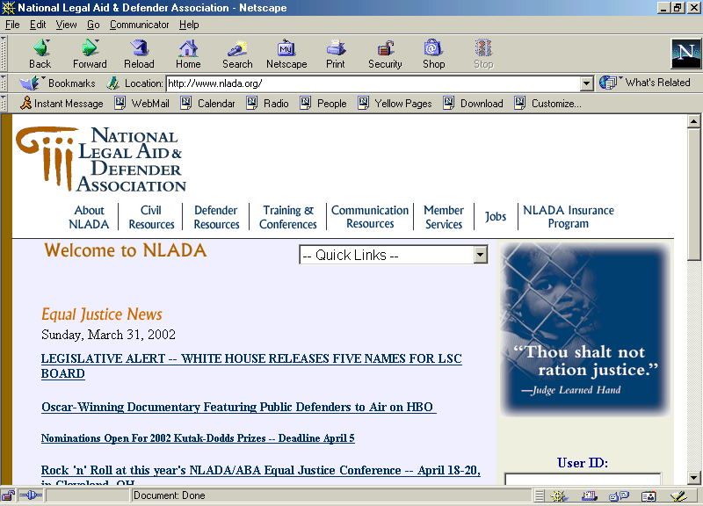
Figure 2. NLDA Web-Site

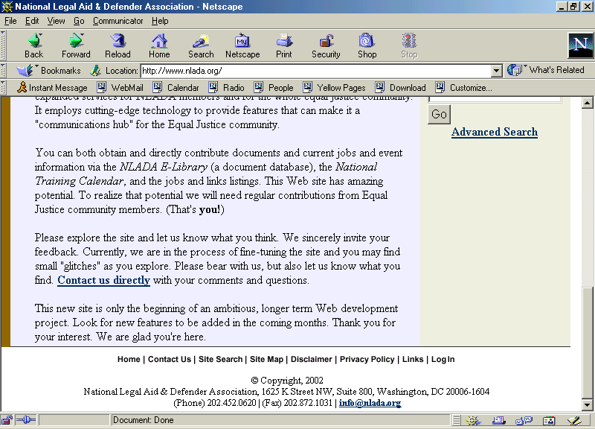
Figure 3. NLDA Web-Site (cont.)
Currently this option is being researched and will finish fact gathering later this week.

- Functionality –
- Scalability -
- Reliability –
- Portability -
- Organizational Constraints –
- Migration Opportunities -
- Cost -

Software Options
The following describe and evaluate several software options for the External Public Relations website and the Internal Site to include the administrative application.
The Project Team identified the current software and found that the workstations at AU had license for Amicus Attorney so that research could be done from that site. Additionally, the workstation had Microsoft Access for reporting printouts.
AU’s Software
- Microsoft Office 2000 Suite – currently installed on workstation
- Microsoft FrontPage 2000 – currently installed on workstation
- Microsoft Outlook 97/2000 - Two workstations have Outlook 2000
- Amicus Attorney IV - one License is loaded on workstation
Customer’s current remote connectivity architecture
JD-Put in picture of Current site at AU
Future Network Architecture (with Hosting capabilities)
JD –PUT in your picture
Future Network Architecture (with remote capabilities)

External Site

HTML Editor (JTD)
An HTML editor such as MS FrontPage provides the software cability for designing, implementing and maintain
- Functionality –
- Scalability -
- Reliability –
- Portability -
- Organizational Constraints –
- Migration Opportunities -
- Cost -

Document Converter (MV)

Introduction:

The HP 9100C is a network device, which converts paper-based documents into electronic data. Paper-based information can be converted to an electronic format and sent whenever and wherever you want. Brochures, contracts, bills of lading or medical images are all compressed and converted to PDF (or TIFF) files that can be sent to several different people-in different places-at once. Color and black-and-white documents are sent by e-mail with the push of a button. The HP 9100C Digital Sender can be installed in about five minutes with no modifications to your IT infrastructure and without extensive user training. Just plug it in and anybody who knows how to send an e-mail can start using the Digital Sender right away.

The steps are as easy as 1,2,3.
Place your document in the automatic feeder,
Type in or select a destination from an address list
Press the green send button.

That's all there is to it. Just like that, your hardcopy documents are converted and compressed into small digital files, complete with high-quality black and white or full color images, and sent to anyone with an e-mail address.

Functionality –
Sends data Via Internet e-mail directly from device itself
Via Fax either through on of the many supported Network Fax Servers or an Internet Fax Service Provide
Via Jet-Send to other Jet-Send enabled network devices
Can send to a PC
Send to a network Printer for printing copies
Send to a Third Party Application

Scalability -
Sending the documents via Internet e-mail to single or multiple e-mail addresses is achieved by connecting the digital sender to an e-mail server supporting SMTP (Simple Mail Transfer Protocol). The connection means providing the e-mail server Network IP address to the digital sender

The table below summarizes the mandatory and optional architecture components for the HP 9100C

E-MAIL  HW component  SW component | MANDATORY  Internet e-mail Server (SMTP-MIME Gateway) | OPTIONAL  LDAP server  WINS/DNS server  HP Jet Admin  HP Address Book Manager  HP Address Book Import
NETWORK FAX  HW component  SW component | MANDATORY  Windows NT computer  One of the supporte Network Fax Products  HP JetAdmin  HP Digital Sender service | OPTIONAL  WINS/DNS server  HP Address Book Manager
INTERNET FAX  HW component  SW component | MANDATORY  Internet e-mail server (SMTP-MIME; Gateway)  Internet Fax Service Provider  HP JetAdmin | OPTIONAL  WINS/DNS server  HP Address Book Manager
JetSend  HW component  SW component | MANDATORY  Destination Jets Send Service | OPTIONAL  WINS/DNS server
PC  HW component  SW component | MANDATORY  Destination PC  HP Digital Sender Link  HP Address Book Manager | OPTIONAL  WINS/DNS server  Adobe Circulate
Copy  HW component  SW component | MANDATORY  Destination supported Printer  HP Address Book Manager | OPTIONAL  WINS/DNS server
Third Party Application  HW component  SW component | MANDATORY  Windows NT computer  HP Address Book Manager  HP Digital Sender Service | OPTIONAL  WINS/DNS server

Reliability – Since the core business of the vendor is to provide a quality product to it’s consumers, the machine must be reliable, otherwise the client would change vendors. A good gauge is to ask the vendor for performance data and to ensure that your needs can be met .
Portability – the Digital Sender is a stand alone Hardware device that can be easily moved. Its dimensions are 11.35x 16.12 x 11.05 inches. Needless to say it’s not a very large machine. As long as there is a network connection jack in the location that you are moving the device itself is easily portable.
Organizational Constraints – There are no organizational constraints.
Migration Opportunities - The HP Open View enterprise-management product portfolio provides comprehensive management capabilities for today's multi-vendor environments, including full support for Windows 2000. HP Web Jet-Admin is the industry's leading network peripheral-management software. HP OpenView solutions are Windows 2000 compatible today, and many HP OpenView customers are already successfully managing their Windows 2000 environments. HP is enabling enterprises of all sizes to seamlessly manage the transition of their business-critical applications and networks to Windows 2000. P recommends upgrading HP Digital Sender firmware and software to the most recent version. Although HP has made every effort to ensure compatibility, the following known issues exist with some applications, and minor problems may arise. During the administrator setup for HP Jetadmin 3.4, a string error and/or invalid directory name can occur. When installing the administrator software, be sure to select Custom. For the HP Jet-admin options, select Extensions only (deselect Utilities), and continue with the installation. Then, install HP Jet-admin version 3.42. When installing, select the Network Printing and Status components of HP Jetadmin 3.42. HP Jetadmin 3.42 is available on the HP Digital Sender CD-ROM Version 4.0.

Cost – Can range from $2,800-$3,700 per device. It all depends on what customization you need.

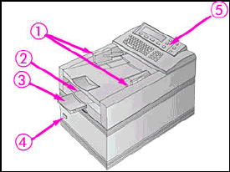
1 - Document Guides
2 - Document Output Tray
3 - Document Output Support
4 - Power Switch
5 - Control Panel

Internal Site

AMICUS Attorney Software (AVP)
The Amicus Attorney case management software program provides to the legal community a case file management software to integrate a laws standard way of doing legal practice; email integration, outlook synchronization, for message transport and receive and additional modules that can eliminate the paper filing into a electronic Library module that stores practice and research sources.

- Functionality – This application software can provide the ability to research client matter files, facts, issues, calendars, time entries, contacts, client documents, phone calls, e-mails, messages, legal research, dockets, conflict checks, business development, and date calculations as well as data management.
- Scalability - With proper planning this software solution is scalable. The vendor can provide upgrades and periodic updates and added features throughout the products life.
- Reliability – This application software option is reliable and as such has the best solution for client research.
- Portability - The specification for the software allows users to access via the web-enabled technology.
- Organizational Constraints – There are organizational constraints as it has users licenses. This option is the based on customers and low needs category.
- Migration Opportunities - This opportunity would be whether the client would be migration the data to another location. If the data is migrated then, how much of the legacy data needs to be transferred and is IPNCR personnel willing to manually transfer thee data. This requires the capability of time and effort as it relates to the moving client data. This is a high risk.
- Cost - This option would be high due to the initial cost for the client since they have non-profit status. Based on either: Advanced edition $399 for 1st user, then each addt’l user in firm would be $299/user which this would be recommended for up to 15 users. If Client/Server is needed, then $499/user but however, this is recommended for up to 200 users. In addition to purchasing,
Customer Service Agreements between the vendor and customer.
Pricing for Amicus: At time of Purchase After purchase
Single User $149 $199
2 to 6 Users $249 $349
For 7 or more $40/user $50/user
Pay per-call $75/call

Amicus will give a discount for IPNCR.

ZOP Software (JW)
- Functionality –
- Scalability -
- Reliability –
- Portability -
- Organizational Constraints –
- Migration Opportunities -
- Cost -

Custom Made Database (JW)
- Functionality – The functionality is limited only by what the IP can afford. This is the best way to meet the requirements and add new functioinality doen the road easily. As the needs of the IP matures the site can mature as well. This option offers the most functionality of any of the applications.
- Scalability – With proper planning his solution can be scaled to any size.
- Reliability – is a performance metric. If the software is developed correctly, it should be very reliable.
Portability – The specification for the software will be specified in the development document. The application should be portable to an application service provider/ Internet service provider ASP/ISP.
- Organizational Constraints – There are no organization constraints. This option is the strongest independent model available.
- Migration Opportunities – This would be a separate cost but easily identifiable by the developer. The first question that needs to be answered by the IP is how much of the legacy data needs to be transferred and is IP willing to manually input the data. This would reduce the cost of the migration. The developer needs to build in the functionality for a batch input of data into the database if the IP is not willing to do the other options.
- Cost – The initial cost is at a medium level. It is not free but it is the most adaptable. It can be ported to different ASP/ISP, which allows the IP to shop for value. The project could be broken into several pices to make it more affordable.

Information Assurance Options

Site Security (MV)
- Functionality –
- Scalability -
- Reliability –
- Portability -
- Organizational Constraints –
- Migration Opportunities -
- Cost –

Backups (JW)
- Functionality – the backups should contain onsite backups 3 times a week and offsite backups monthly. This will ensure recovery form lost data is no more than one day out. In addition, if for some reason the vendor had a catastrophe the IP would only have to reconstitute 1 month of work.
- Scalability – Additional backup procedures could be put in place such as a CD burned for an archive copy of the database. Several other methods do exist but the cost rises with each step. It is a good idea to have the hosting service make an annual copy of the database onto a common transferable format such as CD's. The CD would be housed with an agent for the IP. With this type of archive, the IP can ensure that they can reconstitute operations even in the worst circumstances including if the hosting service should go out of business.
- Reliability – modern backup techniques are very stable. Most commercial offices restore parts of their servers on a regular bases to ensure they can recover lost data. Please note that in case of a loss of the data center a duplicate set of equipment must be purchased to restore the data. If the web site is housed at an ASP/ISP, it will be their responsibility to purchase, setu, and restored the server.
- Portability –In most cases portability is not an issue for backups. The theory behind backups is that the hosting service is responsible for the restoration.
- Organizational Constraints – Commercial Hosting service provide will be more willing to do extra backup services, but there will be a charge for these services. Universities and other groups who have offered to host the site will be less willing to do extra services. It's important that the organization to organization agreement include details about backups and restoration to ensure both groups understand their responsibilities.
- Migration Opportunities –
  - Hosting Service Backup Migration- when the hosting service upgrades their backup system, the IP would need to do a 100% review of the data before the migration to ensure they do not need any old information from a former backup. The IP would request an archival CD be cut after the review. This would ensure that the IP could always recover to a solid baseline.
  - In the case of switching ASP/ISP, service backups would not migrate. Backups are for the web site to recover from computer errors. Since there are many different types of backup software and hardware and typically, the backup system is shared among multiple entities on the server. Transporting the backup system is not a valid option. The IP would request an archive CD be cut after a 100% review. This would establish the current baseline for the IP project that could be migrated to a new ASP/ISP.
- Cost – There are three types of services.
  - There should be no cost for the basic functionality of a standard set of backups the hosting service is doing.
  - There may or may not be a charge for recovery services. Please note that the web site can be reconstituted file by file. The databases are typically all or nothing. So it's important you realize the difference. If a major section of the data base needs reconstituted a database administrator may need to do the reconstitution. This could be a very costly and time intensive procedure.
  - Additional cost may include:
    - Off site backups
    - Restoral
    - Archived CD.

Inter Organizational agreement (JW)
(flesh out later)
- Functionality –
- Scalability -
- Reliability –
- Portability -
- Organizational Constraints –
- Migration Opportunities -
- Cost -

Summary/Conclusion (JD)

